**Self-Declaration of DA expenses on tour**

Certified that I have incurred expenditure of about less than Rs 11250 towards DA expenses during 11th Oct to 25th Oct, 2017 days of Calendar month October, 2017. Please find the bifurcation below for your convenience.

All the days are for only Composite Dearing Allowances.

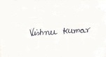

**Vishnu Kumar**

**Engineer (Allahabad)**